Problem: Calculate monthly savings. A Student earns 2000 AED allowance. Spends 1200 AED. Find savings!
Step 2: Inputs & Outputs:
Income = input
Expenses = input
Savings = output
Constraints:
Income must be ≥ 0
Expenses must be ≥ 0
Expenses cannot exceed income
Step 3: Design
3.1 Algorithm
Start
- Take input of income
  - If income < 0 Display "Invalid income" and Stop or ask again.
- Take input of expenses
  - If expenses < 0 OR expenses > income Display "Invalid expenses" and Stop or ask again.
- Deduct expenses from income to find savings.
- Display savings
Stop
3.2 Flowchart
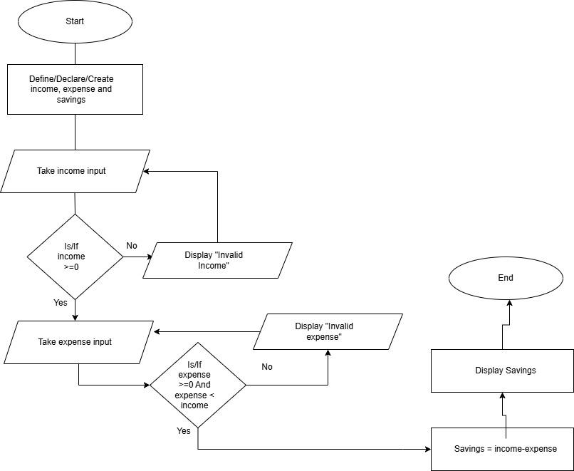
3.3 Test Plan
Test No. | Test Case | Inputs | Expected Output
1 | Valid Input | 1000,500 | 500
2 |  | 1250, 450.5 | 799.5
3 | Invalid Input | 0,200 | Invalid Expense
4 |  | -2000 | Invalid Income
5 |  | 2000, -400 | Invalid Expense
6 |  | 5000, ABC | Invalid Expense
7 |  | XYZ | Invalid Income
8 | Savings Calculation | 2250, 650 | 1600

3.4 Pseudocode
Start
DECLARE income, expense : REAL //Declaring income and expense variables
DECLARE savings = 0 //Declaring and initializing savings variable
DISPLAY “Enter your income”
INPUT income
IF income < 0
Display "Invalid income"
Go to End/Go back to previous step
END IF
OUTPUT “Enter your expense”
INPUT expense
IF expense < 0 AND expense > income
Display "Invalid expense"
Go to End/Go back to previous step
END IF
Savings = income - expense //Assigning result to savings variable
PRINT “Your savings are ” + savings
End
Step 4: Test the Pseudocode
Test No. | Test Case | Inputs | Expected  Output | Pseudocode Output | Result  (Pass/Fail)
1 | Valid Input | 1000,500 | 500 | Your savings are 500 | Pass
2 |  | 1250, 450.5 | 799.5
3 | Invalid Input | 0,200 | Invalid Expense
4 |  | -2000 | Invalid Income
5 |  | 2000, -400 | Invalid Expense
6 |  | 5000, ABC | Invalid Expense
7 |  | XYZ | Invalid Income
8 | Savings Calculation | 2250, 65  0 | 1600

